Question 1
- -1300
- y-y1 = m(t-t1)
y - 20300 = -1300(t-0)
=> y = 20300- 1300t
20300- 1300t >= 0 => t <= 20300 / 1300 = 15.6
2004 <= t < = 2019.6
- vertical intercept => t = 0, y = 20300

Vertical intercept is 20300 and it represents the starting price of car.
t = 2013 - 2004 = 9
y = 20300- 1300 * 9 = 8600
question 2

hours | Amount of water
0 | 0
2 | 0.75
4 | 1.5
6 | 2.25
8 | 3
10 | 3.75
12 | 4.5
14 | 5.25
16 | 6
18 | 6.75
20 | 7.5
22 | 8.25
24 | 9

The graph is a straight line passing through the center
- The vertical and horizontal axis is zero because the line pass through the center.
- 42 hours and 40 minutes
- V=3/8x
Question 3

- 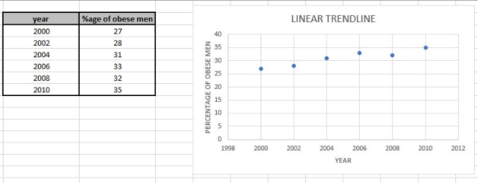
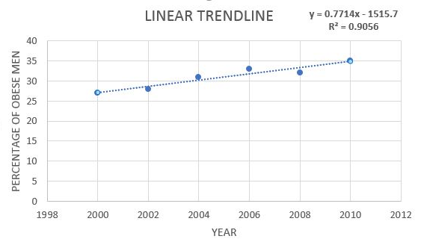
Slope = 0.7714x-15157
0.7714
c. 41%
d. 100%

